Supplementary Data
Table S1: Compositional results (ICP-MS) of Al(OH)₃ coated NPs without treatment.
Samples  (label) | Precursors ratio  MFe₂O₄ to AlCl₃  (M = Mn or Fe) | Elements to detect (mmo/L) |  |  | Core-shell ratio  MFe₂O₄ to Al(OH)₃  (M = Mn or Fe)
 |  | Fe | Mn | Al
MnFe₂O₄@Al(OH)₃  (1) | 1: 3 | 10.29 | 0.98 | 26.79 | 1: 7.3
Fe₃O₄@Al(OH)₃ (1:1)  (2) | 1: 1 | 7.79 | n/a | 3.05 | 1: 1.2
Fe₃O₄@Al(OH)₃ (1:2)  (3) | 1: 2 | 7.92 | n/a | 8.22 | 1 : 3.1
Fe₃O₄@Al(OH)₃ (1:3)  (4) | 1: 3 | 7.98 | n/a | 11.41 | 1 : 4.3

Table S2. DLS results for alumina coated samples before and after filtration
Sample | D_{h} / nm |  | Zeta potential / Mv |  | r₁ / mM⁻¹s⁻¹ |  | r₂ / mM⁻¹s⁻¹
 | Before | After | Before | After | before | after | before | After
1 | 21.0 | 50.7 | +72.3 | +55.9 | 1.47 | 0.65 | 21.4 | 18.0
2 | 18.2 | 50.8 | +70 | +52.5 | 1.65 | 5.36 | 60.5 | 116.6
3 | 21.0 | 49.8 | +49.8 | +38.9 | 3.54 | 3.7 | 81.6 | 121.9
4 | 396.1 | 458.0 | +27.0 | +18.4 | n/a | n/a | n/a | n/a

Table S3. ICP-MS analysis of Al and Fe in pre-wash NPs colloids and the supernatant after wash.
 |  | Pre-wash  NPs colloid | 1st wash  supernatant | 2nd wash  supernatant | 3rd wash  Supernatant
2 | [Fe] mM | 7.79 | Not detected | Not detected | Not detected
 | [Al] mM | 3.05 | Not detected | Not detected | Not detected
3 | [Fe] mM | 7.92 | 0.13 | Not detected | Not detected
 | [Al] mM | 8.22 | 2.96 | 0.07 | Not detected
4 | [Fe] mM | 7.98 | 0.44 | 0.01 | Not detected
 | [Al] mM | 11.04 | 5.55 | 0.15 | Not detected

Figure S1. IR spectrum evolution of Fe₃O₄@Al(OH)₃ samples: a) as-synthesised Fe₃O₄ sample, b) NP 2, c) NP 3, and d) NP 4

Figure S2. TEM images of Fe₃O₄ NPs and Fe₃O₄@Al(OH)₃ NPs. a) Fe₃O₄ NPs prepared from hexane solution, b) NPs 4 prepared from aqueous solution, c) NPs 3 prepared from aqueous solution, and d) NPs 2 prepared from aqueous solution.

Figure S3. XRD pattern of samples: a) NP Fe₃O₄ and b) NP 2

Figure S4. XPS spectrum of sample 4. a) Al_{2p} level data, b) O_{1s} level data, c) Fe_{2p} level data, and d) full scan of XPS spectra.

Figure S5. XPS spectra comparison of Fe₃O₄@Al(OH)₃ samples (2- 4) with different core-shell ratio: a) NP 2, 1:1; b) NP 3, 1:2; and c) NP 4, 1:3.
Figure S6. Adsorption of non-radioactive ¹⁹F⁻ by 5 mg 1 NPs in 5 ml NaF solution of different conditions, monitored by fluoride ion selective electrode.

Figure S7. ¹⁸F-fluoride radio labelling of Fe₃O₄@Al(OH)₃ NPs (2-4) varying the core-shell ratio. Pre-wash results showed that all three samples exhibited a low labelling efficiency, especially 3 and 4. A much higher radiolabelling efficiency were achieved after removal of unstable Al(OH)₃ layer by washing with water 1 or 2 times.

Figure S8. In vivo PET/MRI images of a normal young C57BL/6 mouse using ¹⁸F radiolabelled 3: (a) whole body PET image showing distribution of ¹⁸F 30 minutes post injection (maximum intensity projection, mice in prone position); (b) PET/MRI fused image (coronal section, 0-15 minutes); (c) PET/MRI fused image (coronal section, 105-120 minutes); (d) MR image prior to the injection of NPs, and (e) MR image post the injection of NPs, showing a darkening contrast at lung and live area. Due to the unstable Al(OH)₃ shell, ¹⁸F-fluoride radioactivity was released from magnetic NPs 3 within 15 minutes and localised in bone.
Figure S9. In vivo PET/CT images of a normal young C57BL/6 mouse using ¹⁸F radiolabelled 1: a) 0-15 minutes; b) 15-30 minutes; c) 30-45 minutes; d) 45-60 minutes; e) 60-75 minutes; f) 75-90 minutes; g) 90-105 minutes; and h) 105-120 minutes. NPs 1 obtained by a slow hydrolysis process has a better in vivo stability than NP 3 synthesised by a quick hydrolysis (Fig. S8), which is in consistent with the in vitro studies.
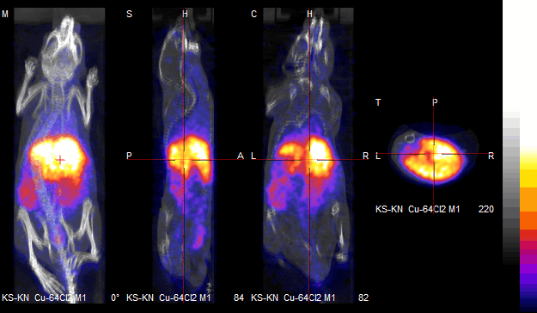
Figure S10. In vivo PET/CT images of a normal young C57BL/6 mouse using ⁶⁴CuCl₂ solution (0-30 minutes).

Figure S11. DLS size distribution of NPs: a) Fe₃O₄ NPs in hexane; b) pre-washed NPs 3 in water; c) post-washed NPs 3 in water; and d) conjugates of post washed NPs 3 and BP-PEG (10K Da). [3] = [Fe₃O₄] ≈ 1 mg/L. Zeta potential was measured in neutral aqueous solution with a pH value ≈ 7.

